## Message protocol

The project will be using low-level message protocol as a more compact way of representing information. It uses numbers, letters, and a separator instead of words, colons and dashes. This protocol is easier for the traffic management system to store and process the data.

The message protocol consists of two parts: cars detected and queue states. The cars detected part contains the binary representation of the number of cars detected at each direction of the intersection, followed by the decimal representation of the time waiting in front of the intersection. For example, “N:1 T:1.00“ means that there is one car detected at the north direction, and it has been waiting for one second. The queue states part contains the representation of the traffic light colors for each direction of the intersection in each queue state. For example, “Q1 | N:G | E:R | S:R | W:R“ means that in the first queue state, the traffic light for the north direction is green, and the others are red. The separator “|” is used to separate the data fields in the low-level message protocol.

|  |  |  |  |
| --- | --- | --- | --- |
| **Content** | **Format** | **Meaning** | **Logic** |
| N/S/W/E | | N:1 | E:0 | S:0 | W:0 | N/S/W/E are the four directions of the intersection: north, south, west, and east. | The traffic light system uses sensors to detect the number of cars at each direction. The number of cars at each direction affects the traffic light color and the queue state selection. |
| T | T: 1.00 | T stands for time. It is a decimal number that represents the time waiting in front of the intersection. | The traffic light system uses timers to measure the time waiting at each direction. The time waiting at each direction affects the traffic flow and the queue state selection. |
| Queues | Q1 | N:G | S:R | This indicates the state of the queues. N:G means the queue in the north direction is green, and S:R means the queue in the south direction is red. | The queue state is determined based on factors like the number of cars and waiting time at each direction. |
| Separator: | “|” | It is a symbol that is used to separate the data fields in the low-level message protocol. | The traffic management system uses separators to enable the parsing of data fields within the message protocol, ensuring there are no limitations on the data fields. |

The sequence diagram illustrates how the Traffic Direction Controller (TDC) and the Traffic Flow Controller (TFC) nodes in the Intelligent Traffic Management System (ITMS) interact with each other to manage the traffic at each intersection. The TDC node oversees sensing the traffic conditions and controlling the light sequence at each direction, while the TFC node oversees exchanging information with other intersections and forecasting the traffic patterns.

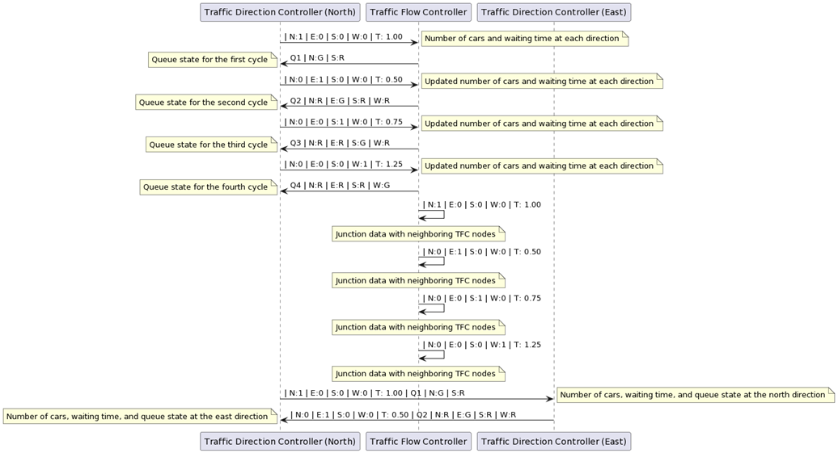

The interaction begins with the TDC node sending the number of cars and waiting time at each direction to the TFC node using a low-level message protocol that uses separators to parse the data fields. For example, “| N:1 | E:0 | S:0 | W:0 | T: 1.00” means that there is one car in the north direction, zero cars in the east, south, and west directions, and the waiting time is 1.00 seconds. The TFC node then sends the queue state for the first cycle to the TDC node using a similar message protocol. For example, “Q1 | N:G | S:R” means that the queue state for the first cycle is green for the north direction and red for the south direction. The TDC node updates the number of cars and waiting time at each direction based on the sensor data and sends it to the TFC node. The TFC node sends the queue state for the second cycle to the TDC node based on the updated data and the predefined algorithms. The TDC node and the TFC node repeat this process for the third and fourth cycles, changing the queue state accordingly.

The TFC node also shares the junction data with neighboring TFC nodes using the same message protocol. This allows multiple intersections to coordinate and optimize the traffic flow. For example, if a TFC node detects a surge of cars coming from one direction, it can inform a downstream TFC node to prepare for increased flow. The TDC node also communicates with other TDC nodes that are part of the same junction or a nearby junction. They share the number of cars, waiting time, and queue state at each direction using the same message protocol. This allows the TDC nodes to adjust their light sequence based on the traffic conditions of the neighboring directions. For example, if a TDC node for the north direction detects that the east direction has more cars and longer waiting time, it can shorten its green time and give more green time to the east direction.